FLORIDA COMPLETE PHASE 1 & 2 MODEL ANALYSIS

Time series plots of Florida HPI and unlagged predictor variables
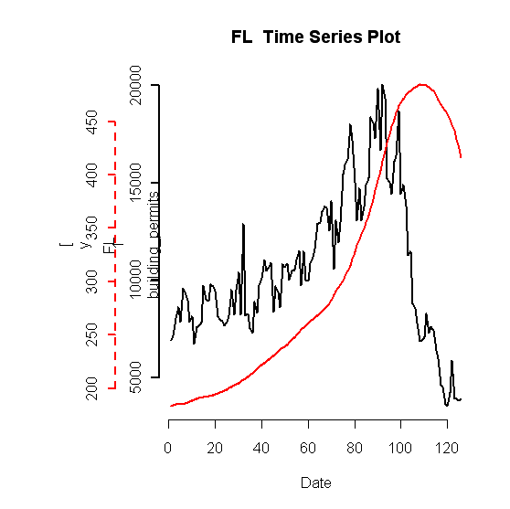
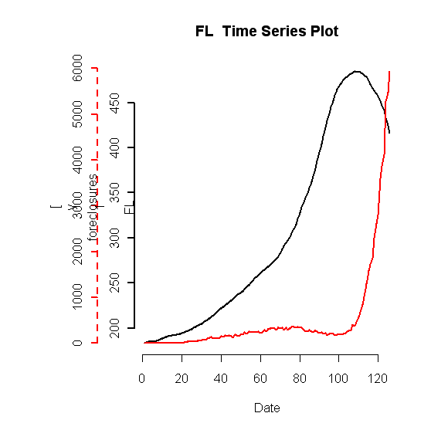
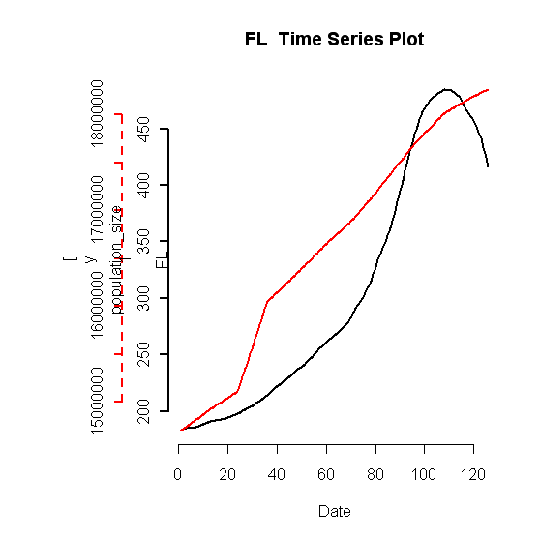

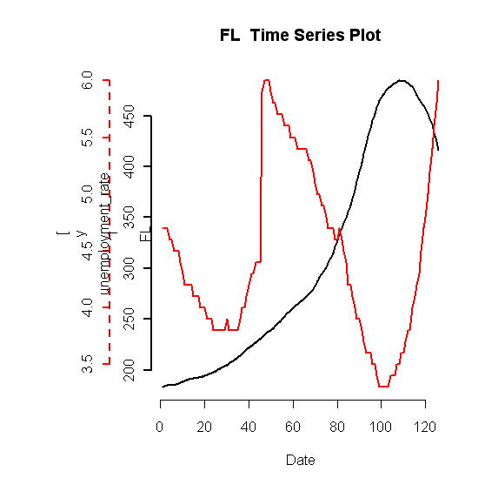
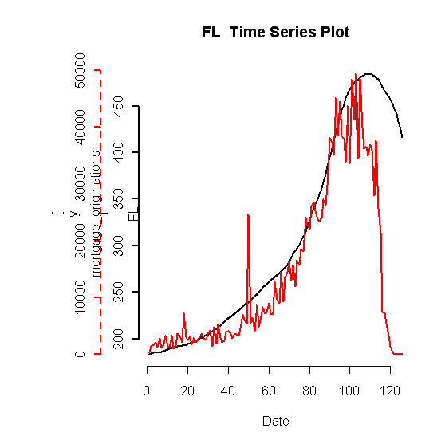
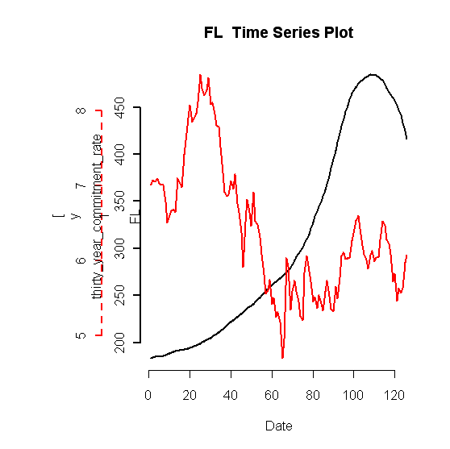
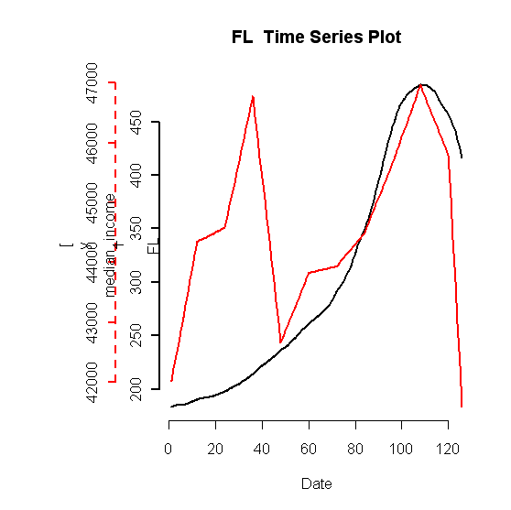
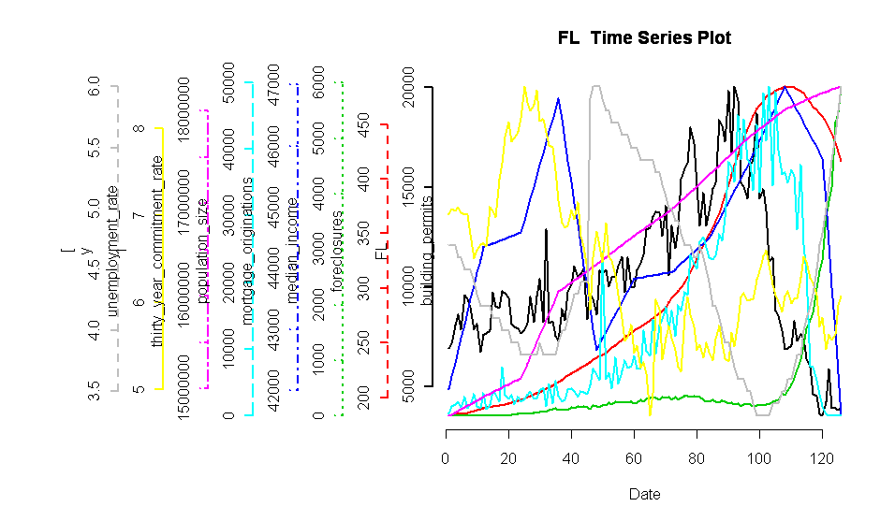

Based on these time series of the data, we picked these lags to test:
median_income | thirty_year_commitment_rate | mortgage_originations | unemployment_rate | population_size | foreclosures | building_permits
0 | 0 | 0 | -4#-3#1#3 | -6#3 | -3,-1 | 0

Plots of lagged vars and FL HPI:

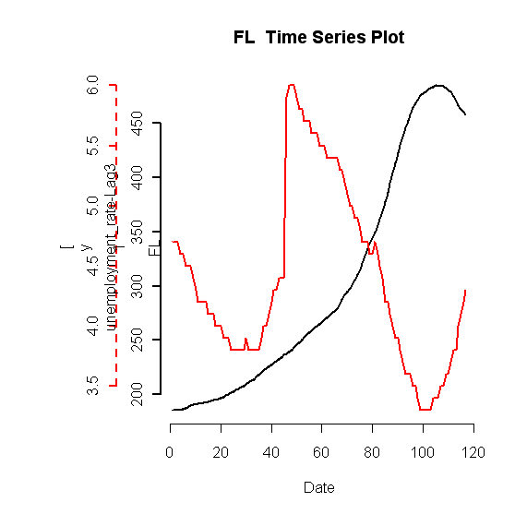
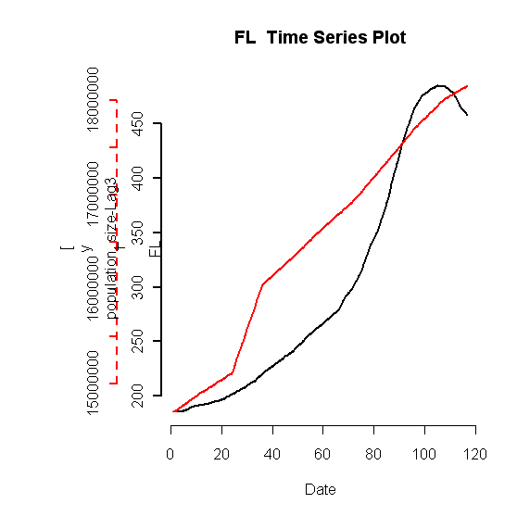
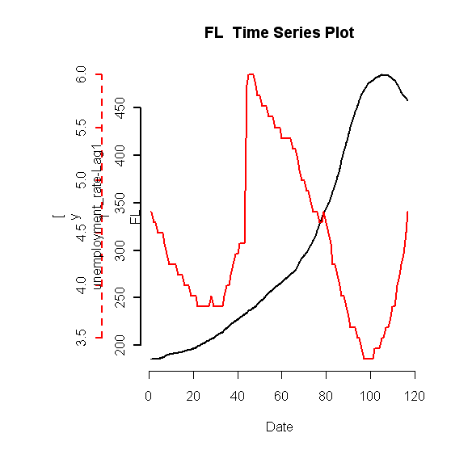
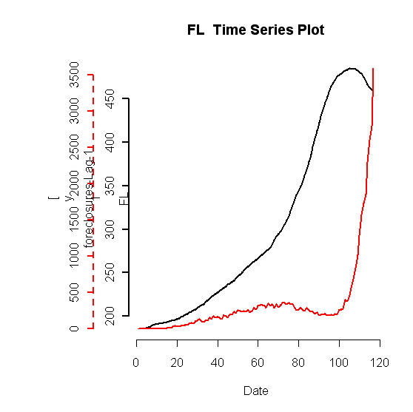
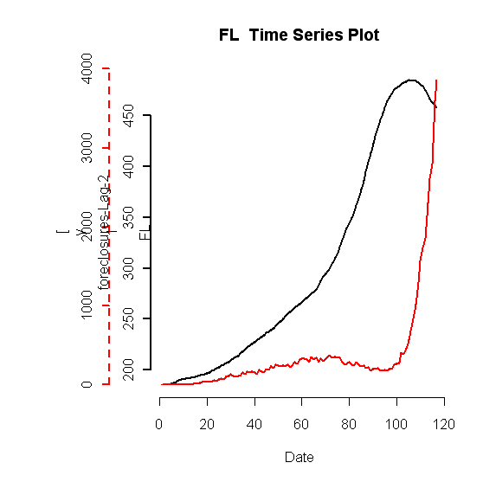
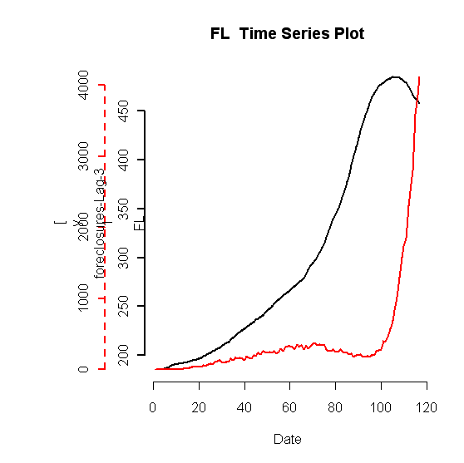
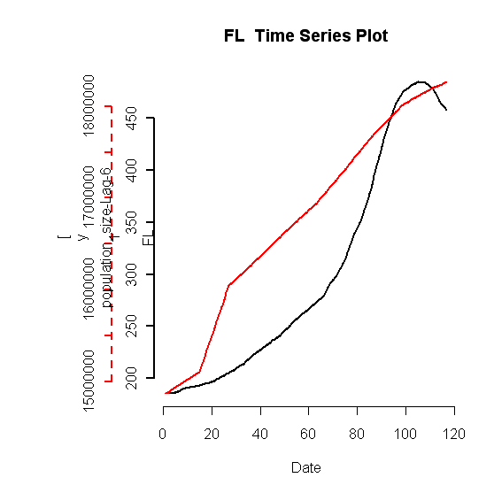
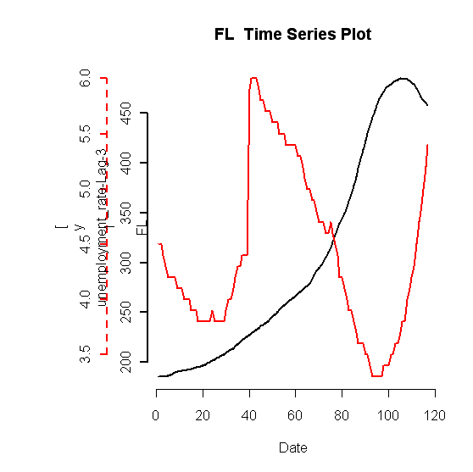
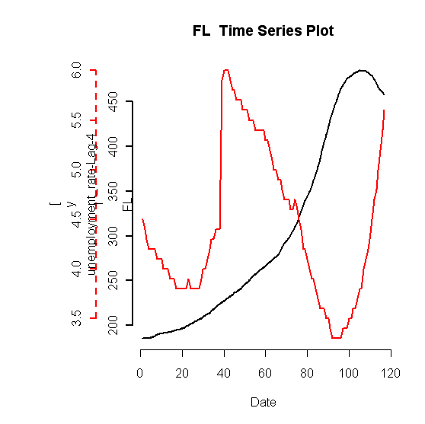
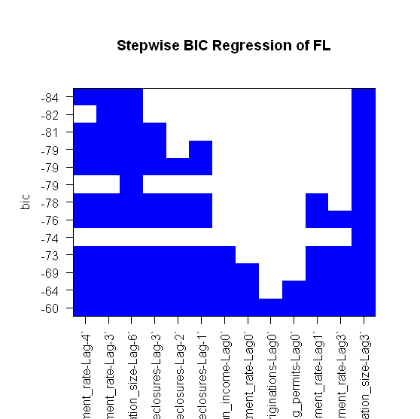

Fit rlm with all lagged vars:
Call: rlm(x = shifted.multivar.test.data.vector[, 1:(n - 1)], y = shifted.multivar.test.data.vector[,
n])
Residuals:
Min 1Q Median 3Q Max
-0.0159690 -0.0020288 0.0008338 0.0045595 0.0295564

Coefficients:
Value Std. Error t value
unemployment_rate-Lag-4 -0.0712 0.0162 -4.3983
unemployment_rate-Lag-3 -0.0836 0.0165 -5.0723
population_size-Lag-6 1.3061 0.4229 3.0884
foreclosures-Lag-3 -0.0026 0.0016 -1.6460
foreclosures-Lag-2 -0.0026 0.0015 -1.6699
foreclosures-Lag-1 -0.0026 0.0015 -1.7549
median_income-Lag0 -0.2167 0.2059 -1.0522
thirty_year_commitment_rate-Lag0 0.0009 0.0024 0.3597
mortgage_originations-Lag0 -0.0002 0.0010 -0.2033
building_permits-Lag0 0.0017 0.0045 0.3742
unemployment_rate-Lag1 -0.0285 0.0176 -1.6213
unemployment_rate-Lag3 -0.0237 0.0160 -1.4781
population_size-Lag3 2.9363 0.4187 7.0134

Residual standard error: 0.005344 on 103 degrees of freedom

Fit rlm with unlagged vars:
Call: rlm(x = test.data.vector[, 1:(length(test.data.vector) - 1)],
y = test.data.vector[, length(test.data.vector)])
Residuals:
Min 1Q Median 3Q Max
-0.013701 -0.002252 0.001575 0.006133 0.047483

Coefficients:
Value Std. Error t value
median_income 0.2237 0.1666 1.3423
thirty_year_commitment_rate 0.0002 0.0030 0.0686
mortgage_originations 0.0002 0.0011 0.2014
unemployment_rate -0.1259 0.0219 -5.7532
population_size 2.9903 0.3543 8.4397
foreclosures -0.0009 0.0017 -0.5132
building_permits 0.0040 0.0051 0.7731

Residual standard error: 0.007476 on 118 degrees of freedom

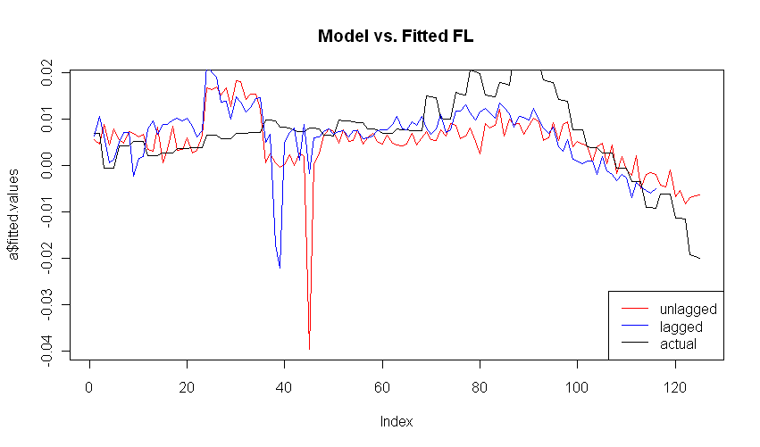
Lagged regression residuals analysis:
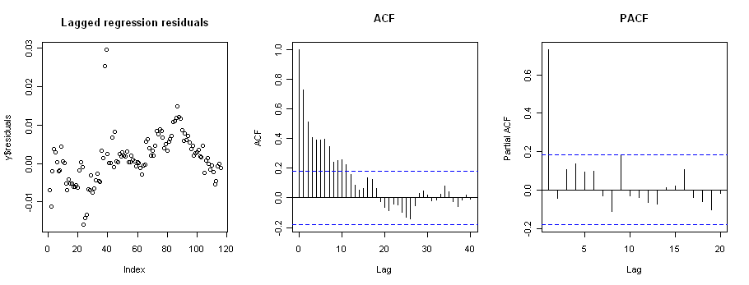

Unlagged regression residuals analysis
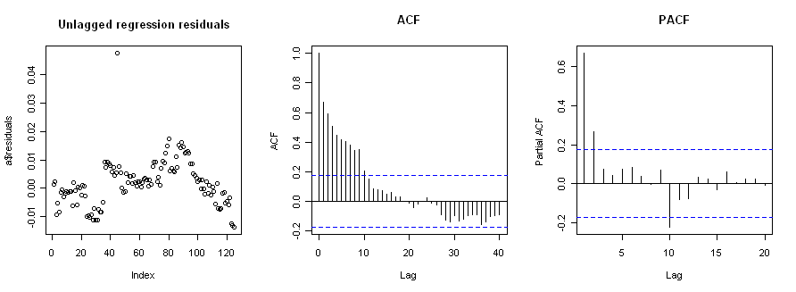

PACF shows k=2
Augmented Dickey-Fuller Test

data: y$residuals
Dickey-Fuller = -3.5887, Lag order = 2, p-value = 0.03735
alternative hypothesis: stationary

Residuals are stationary so phase 1 complete. Continue to Phase 2.

First, check Box-Ljung.

Box-Ljung test

data: y$residuals
X-squared = 220.422, df = 12, p-value < 2.2e-16

Box-Ljung fails. Implies residuals are autocorrelated. So we will now model the residuals as time series.

EACF shows that we should try to fit ARMA(1,0).

Fit ARMA:
Series: y$residuals
ARIMA(1,0,0) with non-zero mean

Call: arima(x = y$residuals, order = c(1, 0, 0))

Coefficients:
ar1 intercept
0.7356 0.0011
s.e. 0.0624 0.0015

sigma^2 estimated as 1.921e-05: log likelihood = 464.91
AIC = -923.82 AICc = -923.61 BIC = -915.56

Check adequacy of ARMA
> Box.Ljung.test(arima.fit$residuals,lag = 12, adj.DF = 12-params)

Box-Ljung test

data: data
X-squared = 12.6459, df = 11, p-value = 0.3171

The mean equation passes.

> Box.Ljung.test(arima.fit$residuals^2,lag = 12, adj.DF = 12)

Box-Ljung test

data: data
X-squared = 24.6408, df = 12, p-value = 0.01662

Residuals^2 fails. GARCH modeling needed.

FIT GARCH: Garch estimates
mu ar1 omega alpha1 beta1
4.111261e-04 3.241833e-01 3.089253e-06 1.000000e+00 2.568742e-01

Check adequacy of GARCH model (using standardized residuals):
> sresi=garch.fit@residuals/garch.fit@sigma.t
> Box.Ljung.test(sresi, lag = 12, adj.DF = 12-meanParams)

Box-Ljung test

data: data
X-squared = 10.337, df = 11, p-value = 0.5004

> Box.Ljung.test(sresi^2, lag = 12, adj.DF = 12-volParams )

Box-Ljung test

data: data
X-squared = 5.7986, df = 10, p-value = 0.8319

